A000-China-Hongshan-Jade-Liaoning-Pig Dragon-Torus-Open-Iconic Porcine-4700-2920 BCE

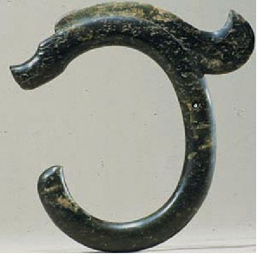

**Case no.:**

**Accession Number:**

**Formal Label:**

**Display Description:**

**LC Classification:**

**Date or Time Horizon:**

**Geographical Area:**

**Map:**

**GPS coordinates:**

**Cultural Affiliation:**

**Media:**

**Dimensions:**

**Weight:**

**Condition:**

**Provenance:**

**Discussion:**

**References:**

This elliptical porcine torus is open at the front with its “tail” and its blunt snout (suggestively of the non-domesticated *Sus scrofa* or wild boar) are opposed. To add motion to this more serpentine shape, a flowing mane has been added. Atlantika Collection.